**4D SPED practical session**

**I) INDEX/ MapViewer - Single phase material: Cu device**

This is a small scan extracted from a microelectronic device and focused on the cross cut of a single copper line. The sample is highly twinned and contains overlapping grains.

The session is devoted to:

- handling the tool

- generating an orientation map

- highlighting relevant structural features through VDF, CCM

- using Multi-Indexing.

**INDEX**

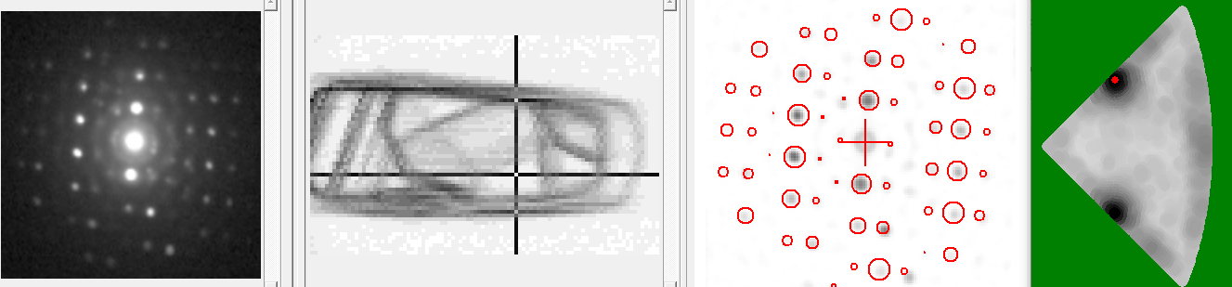

- launch INDEX / start a new project / save the project in the proper directory

- insert the blo file (… *Orientation\Cu device\Cu Y5 detail_CROP.blo*), move around to see the patterns

CCM (Correlation Coefficient Map)

- menu ‘*Block-File\Correlation coefficient map*’, ‘Start’ and import the map with ‘-> Map’

Notice the grain (twin) boundaries, the progressive change in the pattern when moving from one grain to the other

Insert templates

- menu ‘*Templates\View template list*’, button ‘*Add bank*’, select ‘*Bank_A200kV_[Cu]_50_1_r4 Ext.bnq*’

Move around, notice the discrepancies, select a reasonable pattern

Camera length

- tabsheet ‘*Camera length*’, button ‘*Scan camera lengths*’, adjust range, select a proper value

Generate result (*.res) file

- uncheck ‘*Normalize*’ in ‘*Picture*’ tabsheet

- menu ‘*Index block file*’ / start

**MapViewer**

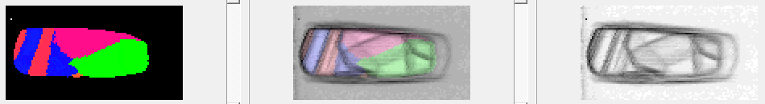

- launch MapViewer

- menu ’*Files\Open Result File*’ select *.res file

- *Viewer: Index*, select proper *Min value* and ‘*Disable points with index below min*’

- explore viewer and facilities

- viewer ‘*disorientation’*, measure disorientation across a twin boundary

- viewer ‘*Pole figure (line)’*, explore the {111} pole figure

*-* viewer ‘Grain boundaries’, extend -> *‘Special boundaries’/ Add Grain boundaries Sigma_3*

Imported map

- generate CCM with **INDEX** and ‘*Save to clipboard’*

- *Viewer: Imported map*, *‘Import from clipboard’*

- *Viewer:* *Combined map*, combine two maps

**INDEX**

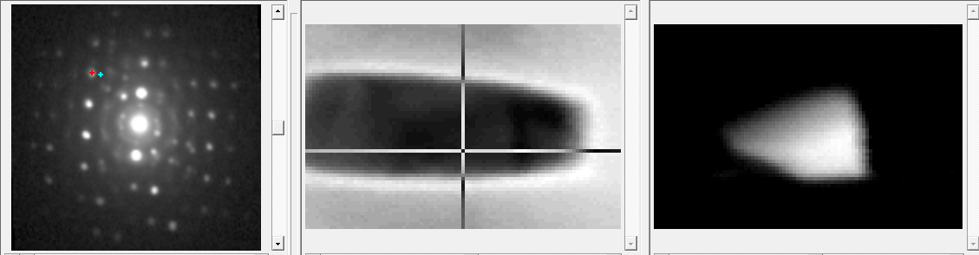

Virtual dark-field images

- menu ‘*Block-File\Virtual dark-fields*’ select a reflection by moving the red aperture, click on ‘*Built VF’* button

- explore ‘*Combined masks*’ (add, subtract)

- copy the image to clipboard (right click)

The resulting grain selected VDF can be imported into MapViewer through the clipboard

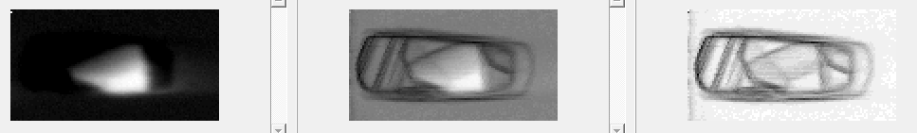

Frozen Template Virtual Dark Field image (FTVDF)

* Tabsheet FTVDF: select a grain and ‘Compute current component’

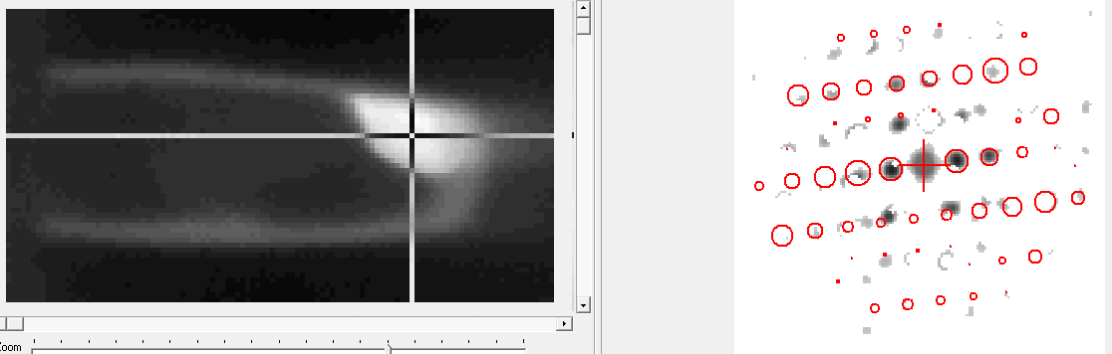

Multi-indexing

- manual procedure: check ‘*De-convolution*’ and press *’Re-Index’* button

The result is sensitive to the template reflection size (red disk size)

- automated procedure: check ‘*De-convolution*’ and uncheck ‘*Normalize*’ in ‘*Picture*’ tabsheet

- menu ‘*Index block file*’ / ‘*Multi-index*’ box, select ‘*Overlapping g.*’ and select 3 ‘*runs*’

- change the result file name (optional), then ‘*Start*’

Note that the indexing speed dropped by a factor of 3 (for 3 iterations/runs)

**MapViewer**

* Launch the *.res file
* Uncheck successively phase 1 and 2 and adapt Index threshold at each run
* Notice the colour change from one run to the next one

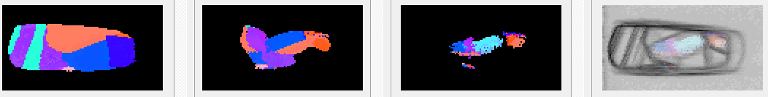

**II) INDEX / DiffGEN – Al-Mn-Ni-Cu-Zr aluminium alloy processed by laser powder bed fusion**

An aluminium alloy containing intermetallic phases

The session is devoted to:

- handling phase identification

- generating templates

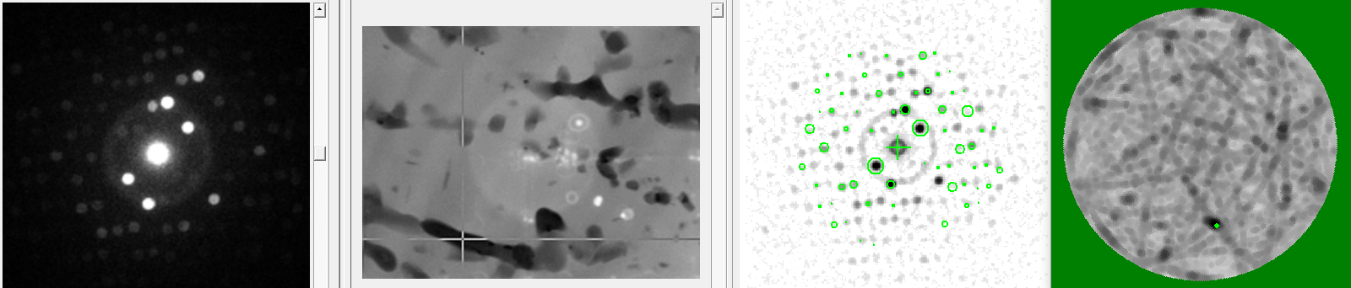

**INDEX**

- launch INDEX / select project (*…\Phase\Fe NS\Al alloy (additive manufacturing)\ project to start.ixp*)

- adapt camera length

Notice the matching score decrease when an intermetallic phase is selected

Import a set of templates

- menu ‘*Templates\View template list*’, button ‘*Add bank*’,

select ‘*Bank_A200kV_[Al 60Mn 11Ni]_100_0.27_r2.bnq*’

Move around, notice the automated selection of phase (change of template color)

**DiffGEN** Generate a set of templates (*AL Fe Ni*)

- launch DiffGEN

Explore the main window

- activate the ‘Structure’ window

Explore the structure window

- note that by default settings is for Al and the corresponding total diffracting intensity

‘Diff.Int.’ is of the order of 600 to 700

- with menu ‘*Import Structure*’, select the proper directory and import ‘*Al9 FeNi.cif*’

Warning: most but not all *.cif files are fully compatible with this import facility

- reduce ‘excitation error’ using ‘Diff. Int.’ as a guide down to ~0.3

- reduce ‘Max angle(°)’ down to 2°

- menu ‘*create bank*’, select the proper directory and ‘*create*’

- change ‘Step counts’ to 100 and generate an additional *.bnq file

**INDEX**

- menu ‘*Templates\View template list*’, button ‘*Add bank*’,

select the newly generated *.bnq file (with 50 step counts)

- add the additional set of templates (with 100 step counts) and compare

- increase ‘Max test count’ on ‘recognition page’ and note the change on the ‘Index map’

- compare ‘Fast Marching’ and ‘Full Matching’

- menu ‘*Index block file*’ generate a *.res file (use ‘Fast matching’ unselect one of the  
 redundant Al Fe Ni bnq file)

**MapViewer**

- lauch MapViewer

- menu ’*Files\Open Result File*’ select *.res file